Latest Processors

1. Intel – Core Ultra (2025)
- Intel’s newest processor for laptops and desktops.
- Works with two types of cores:
  - Performance Cores (P-cores): for heavy tasks like gaming, coding, video editing.
  - Efficiency Cores (E-cores): for light tasks like browsing, background apps.
- Speed: up to 5.6 GHz
- Special feature: has AI Engine (NPU) → helps in AI tasks like photo editing, speech recognition.

2. AMD – Ryzen 9000 (Zen 5)
- Competes with Intel.
- Ryzen 9 9950X3D is the latest gaming processor.
- 16 cores → means it can do many tasks at the same time.
- Uses a special technology called 3D V-Cache → gives extra memory inside processor for faster gaming.

3. AMD – Threadripper 9000 (Workstation CPU)
- Very powerful, not for normal users.
- Used in servers, animation, AI training, data centers.
- Up to 96 cores – imagine 96 workers working together!

4. Qualcomm – Snapdragon X2 Elite (Laptop CPU, 2025)
- Made for Windows laptops.
- Very fast and battery-friendly.
- Has built-in AI features.
- Based on ARM design (same family as mobile processors).

🌟 Key Trends in Latest Processors
- More cores = more multitasking
- AI support inside processor (new trend)
- Smaller size (3 nm, 4 nm chips) → more power-efficient
- Supports faster RAM (DDR5) and storage (PCIe 5.0)

✅ In short:
- Intel → Good for balanced work + AI.
- AMD Ryzen → Best for gaming.
- AMD Threadripper → Best for professionals and servers.
- Qualcomm Snapdragon X2 → Best for thin, long-battery laptops.

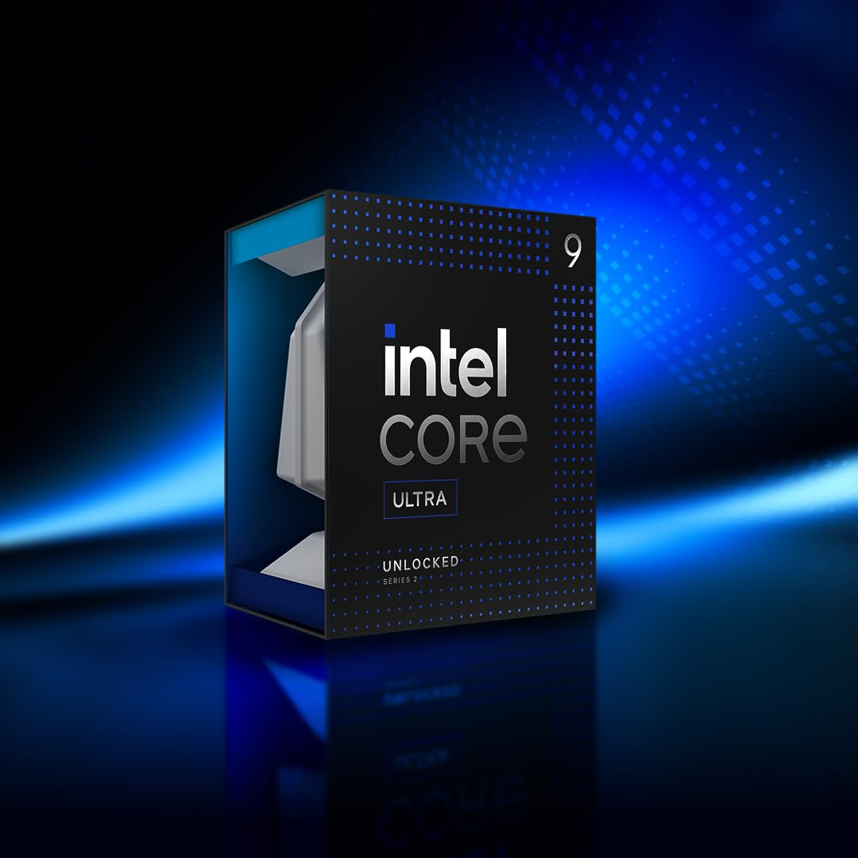

The latest Intel processor as of September 2025 is the Intel Core Ultra 9 285K.

🧠 Key Specifications
- Cores & Threads: 24 cores (8 Performance + 16 Efficient) and 24 threads
- Clock Speeds:
  - Base: 3.7 GHz (P-cores), 3.2 GHz (E-cores)
  - Boost: Up to 5.7 GHz (P-cores)
- Cache: 36 MB Intel Smart Cache
- Power Consumption:
  - Base Power: 125W
  - Maximum Turbo Power: 250W
- Socket: LGA 1851 (requires compatible Z890 motherboard)
- Architecture: Arrow Lake
- AI Performance: 36 TOPS (Tera Operations Per Second)

